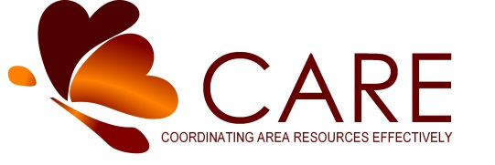

TITLE: Program Support Staff
TYPE: Part Time TIME: 24 Hours/week STATUS: Non-Exempt
ORGANIZATION: Aitkin County CARE Inc., Aitkin, MN 56431
Aitkin County CARE, Inc.’s purpose is to enhance and promote the independence, dignity, value and well-being of seniors, disabled adults, and caregivers.
Aitkin County CARE Inc. partners with local government, businesses, nonprofits and the community to provide innovative and quality services.
Qualifications
Two years of experience working with family caregivers, disabled and/or aging adults
Excellent communication (written and oral) skills
Demonstrated ability to maintain confidentiality and use appropriate professional judgment based on best practices, ethical and legal considerations
Must have auto insurance coverage that meets the minimum requirements of Minnesota State Law on the vehicle used for work
Demonstrated ability and knowledge in respecting the history, traditions, values and family systems of clients
Responsibilities
Acts as an ambassador for CARE programs; includes senior groups/facilities, health and human services, faith communities, businesses, schools, media outreach, etc.
Collaborates with other agencies to improve care of clients and caregivers
Promote programs to potential volunteers, people in need of our services and the community at large
Compiles and maintains records and information for grant and/or agency reporting
Process incoming telephone calls and clients entering office for information as needed
Fill in for respite workers/homemakers as needed
Support evidence based programs as needed
Fill in for NAPS coordination and deliver MOW as needed
Staff CARE office as needed
Support all Administrative staff as assigned
Works collaboratively with CARE staff to ensure seamless service delivery
Receives client referrals from various agencies and community members; provides referrals
Support Senior Companion/Volunteer Coordinator in collaboration with Lutheran Social Services
Must have auto insurance coverage that meets the minimum requirements of Minnesota State Law on the vehicle used for work

Desired Qualifications
Demonstrates passion for improving the quality of life for seniors and disabled adults
Ability to effectively use office equipment (i.e. computers, fax machine, telephone)
Knowledge of Microsoft Office products
Knowledge of internet navigation and social media

Aitkin County CARE Inc. is an equal opportunity employer

